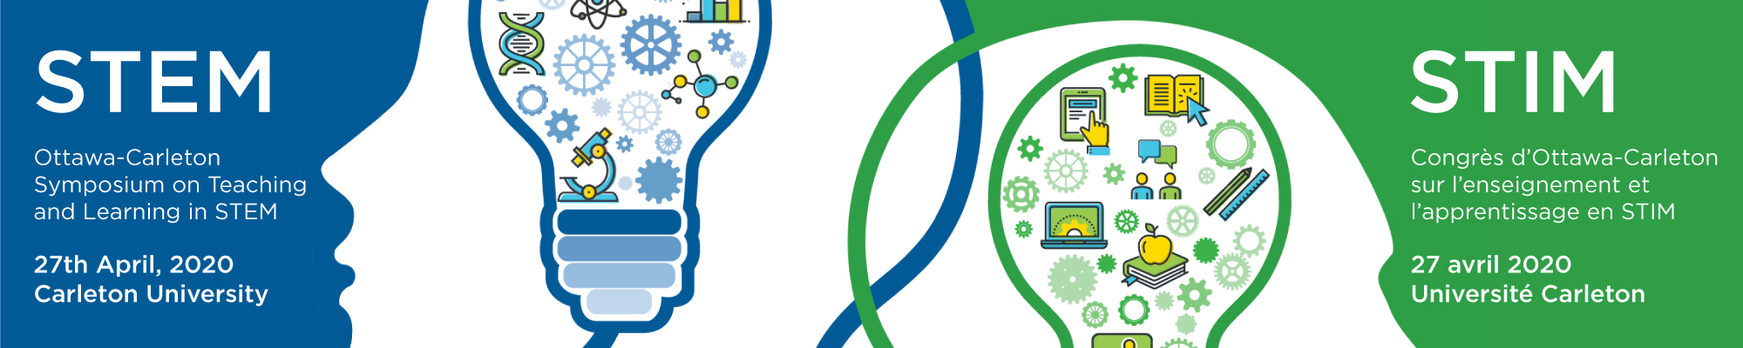

Call for Proposals:
Carleton University is pleased to host The Ottawa – Carleton Symposium on Science, Technology, Engineering & Mathematics (STEM) Teaching and Learning on April 27, 2020.

The cross-faculty symposium is a venue for communication and collaboration between scholars from Algonquin College, Carleton University, La Cité, and the University of Ottawa who are interested in engaging in practical and theoretical approaches to STEM education.

For the third annual Ottawa-Carleton Symposium, we invite you to submit proposals for talks and interactive workshops that address the following themes as they relate to STEM education:

- Aligning teaching practice with teaching theory.
- Threshold concepts, complexity or misconceptions
- Active and experiential learning
- Addressing student communication skills
- Equity and diversity in education

The deadline for proposal submission is Thursday, March 5, 2020. We welcome proposals from all who want to share and contribute to the discussion on STEM education, whether it is experience, practice or research based.

Please submit proposals to https://bit.ly/cu-stem
Submissions are encouraged from faculty, staff, and students (undergraduate and graduate).

